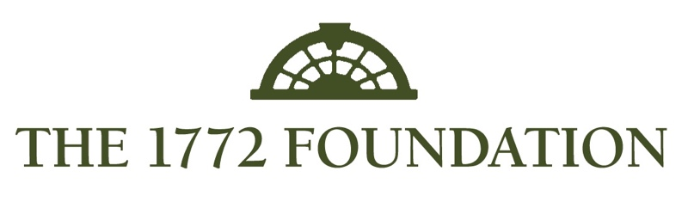
In cooperation with
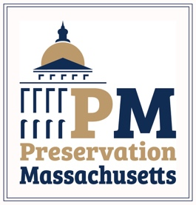

You must answer the following questions in order to complete our online letter of inquiry form for the 2022 grant round. You can use this document to write and refine your answers and then “cut and paste” into our online form. There is no way to “save” your progress once you begin filling out the online form.

1.) Name of Organization:

2.) Contact Name:

3.) Contact Mailing Address (Street, City, State, Zip).

4.) Contact Email Address:

5.) Contact Phone Number:

6.) Resource or Organization’s Website:

7.) Name of Historic Building:

8.) Address of historic site/resource (please use street, city, state, zip format):

9.) Amount of grant requested (up to $10,000):

10.) Purpose of grant: You will need to select from the following options – more than one option may be selected.
-Exterior painting/finishes/surface restoration
-Installation or upgrade of fire detection/lightning protection/security systems
-Repairs to/restoration of porches, roofs, windows
-Structural foundation and sill repair/replacement
-Chimney/masonry repointing.

11.) Briefly describe the work this grant will fund: Be sure to review what work and projects are eligible on our program webpage. Here is where you make the case for your project and historic property. Be concise, clear and convincing.

12.) What are the matching funds you plan to have for this grant?

13.) Are the matching funds already in place?

14.) If no, please explain.

15.) What is the timeline to complete the project? All projects must be completed by December 30, 2022.

16.) What is the ownership status of the site/resource? Properties must be owned by a 510(c)3 organization or under a long-term lease.

17.) Is there a current maintenance plan for the resource/site?

18.) If no, please describe why and if you plan to create and implement a maintenance plan.

19.) What community/region does your organization serve?

20.) Is there anything else you wish to share or that we should take into consideration?

20.) Pictures – the last section is where you will upload 3 photos of the historic resource/site/ Please include at least one picture that shows the front of the building (current photo) and any that show the conditions this grant would address.

Please click the “submit” button and your contact email should receive an automated response. Our staff will follow up with you in a few days to confirm receipt.

Please do not email or call unless you have not received a confirmation within one week of your submission. Thank you for your cooperation and patience.

Erin Kelly
ekelly@preservationmass.org
617-723-3383 (x-102)

